Relations between water availability, multiple uses of water and land use in a micro-catchment in the Colombian Andes

Thesis research for the title of MSc in Sanitary and Environmental Engineering Universidad del Valle-CINARA, Colombia

Clara Roa-Visiting Research at the Centro Internacional de Agricultura Tropical CIAT, Colombia

c.roa@cgiar.org

A.A. 6713 Cali Colombia

+572-4450000 EXT 3335

SUMMARY

Within the framework of the project "Youth in Research" coordinated by the Communities and Watersheds program at the International Center for Tropical Agriculture - CIAT, and funded by the Kellogg Foundation, the youth from the Los Sainos watershed (447 Ha) prioritized water availability in relation to water quality and land use, because of the scarcity periods suffered by the watershed community in recent years. This work consisted of a participatory research with youth of the watershed to answer the following question:
Where are the hot spots in the micro-watershed that through better management practices could contribute to reduce the risks of the community to experience water shortages and deterioration of water quality for all uses in the watershed?

To answer this question we addressed the following:
¿What are the water needs of a rural family for domestic and productive uses?
¿What is the water supply in the watershed and does it satisfy the needs for the zone?
¿What is the relation between land use and water quality?

To quantify consumption and water use, simple equipment was used such as chronometers, recipients, and burettes; and for quality measurements, the equipment used was Hach© for pH, dissolved oxygen, turbidity, conductivity, total dissolved solids, calcium hardness and total hardness and the Oxfam© del Agua equipment for fecal and total coliformes.

The sampling and measuring period was a whole dry season (June to August 2005). It was found that water availability satisfies the current water needs, although with a reduction of water availability of between 15% and 20% the community would start to experience scarcity. Because the system of water supply does not have any treatment for coliformes, they are present even in protected areas, and all individual households need to treat the water for domestic consumption. A close relationship between land use and water quality is demonstrated. The negative impacts on water quality were clearly determined in the downs stream from the discharges of pig manure without treatment and downstream discharges from septic tanks with poor or no maintenance. The quality parameters with greater variability and land use dependent are conductivity, total dissolved solids, fecal and total coliformes, nitrates and phosphates. Other parameters such as temperature, pH, dissolved oxygen, turbidity, calcium hardness and total hardness depend more on topography and land erosion.

Great difference in water technologies are seen between the upper, middle and low sections of the watershed. The majority of the houses in the upper catchment have biodigestors, use less water in cleaning pig houses, and use sand filters; these technologies are in some cases, unknown to the people in the middle and low areas. It was showed during this study that these technologies were efficient because they reduce water pollution to the streams, improve water quality water for human consumption and allow a more efficient water use. Among the strategies for a more efficient water use, the community identified the implementation of these technologies in the whole watershed, achieving the support from the governmental institutions to improve and maintain these technologies, and the willingness of landowners to protect the streams and riparian areas.

Localization

The micro-catchment of Los Sainos is located in the Municipality of El Dovio, and includes the communities of Bellavista and Los Sainos (see, figure 1). The Municipality is located in the North East of the Department of the Valle del Cauca, in the Western Andean range. Its area is 447 hectares. The altitude ranges from 1870 meters above sea level to 1570 meters. In Bellavista the streams of Los Sainos and Arenosa originate. These streams join together in the lower part of the catchment, before flowing into the Quebradagrande, which flows into the río Dovio, then into the río Garrapatas, into the río Sipí, and finally from the San Juan into the Pacific Ocean. In the micro-catchment there are 58 homesteads, two schools, a guest house, and a community hall, in which a women organization (Las Señoras del Buen Sabor) prepare food.

Figure 1. Micro-catchment Los Sainos
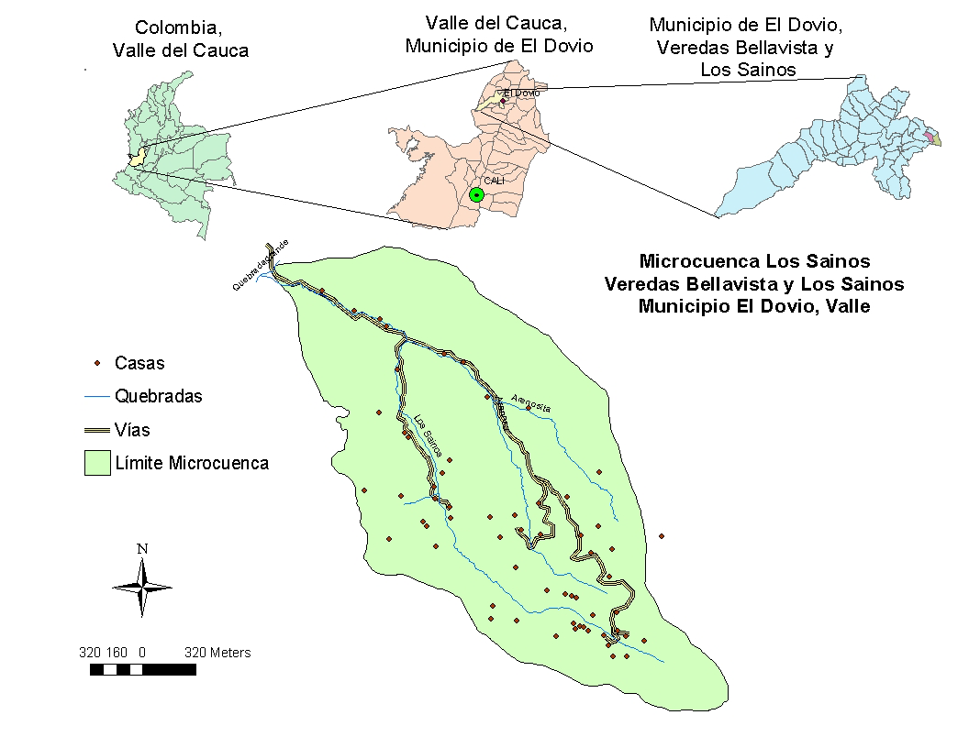

The general objective was to generate options for a more efficient water use and evaluate their feasibility, in the Los Sainos micro-catchment, on the basis of the relationship between water availability (quality and quantity), multiple uses of water and land use.

In order to reach the objective, it was necessary to quantify water consumption for multiple uses in the catchment, and compare this with figures from literature; to analyse water quality along the catchment and relate this to land use; and to quantify (in a preliminary manner) water availability during the dry period and compare this with the water demand. Based on that, recommendations and options for more efficient water use in the catchment were determined.

Methods and results

Participation
A relevant factor within the methodology was the participation of the community in the sampling and analysis of all the measurements. The ones who mainly participated were children and youth from the region. This generated more interest of these persons to generate solutions for their problems and a better sense of ownership to continue with activities that can improve their quality of life.

Water consumption
Water consumption for both domestic and productive uses was measured in 18 houses (6 each in the upper part, middle part and lower part of the catchment). Measurements were taken by chronometer, containers and survey forms (see pictures).

Foto 1 Foto 2 Foto 3 Foto 4 Foto 5

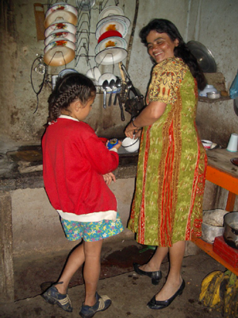
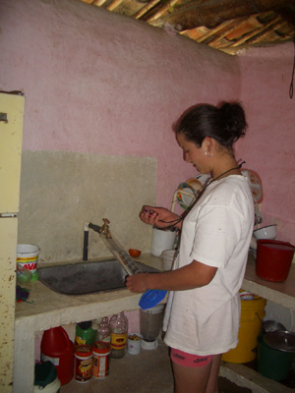
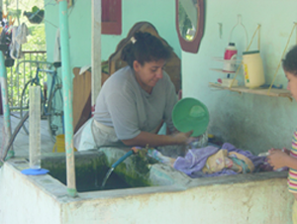
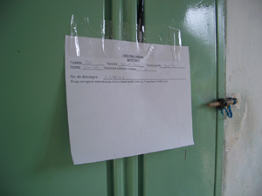
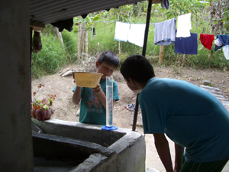

Average consumption for domestic activities is 67 lpcd. This value is well below the 125 lpcd, which is the recommended design norm for rural water supply systems in Colombia (Crcho, 1997). However, including the other uses, the total consumption reaches 191 lpcd. This consumption represents an average family from that zone of 4 persons, 1 dog, 10 chickens, 5 pigs, 5 heads of cattle, 350 m2 of crops and an ornamental garden around the homestead. If families are involved in processing (washing) of coffee beans the consumption increases up to 249 lpcd (figure 2)

Figure 2: water consumption in a rural micro-catchment in the Colombian Andes

Water availability
Water quantity was measured at the two main water supply system intakes in the Los Sainos stream (see picture 7). The flow at the small intake in the upper part of the catchment is 0.1 l/s, and at the bigger one in the middle part of the catchment is 1 l/s. This amount was compared with the consumption at the households that use these intakes (8 homesteads in the upper part and 17 in the middle and lower part).

The results show that during the time of the measurements (June until August 2005, i.e. the dry period) water availability is sufficient for the multiple uses of water. In case the flow would go down with a further 15-20%, there would be less supply than demand (see figure 3).

Figure 3. Water availability and consumption from the small intake

Foto 7. Flow measurement at the intake
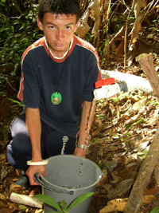

Water quality and land use
A satellite picture was used with basic field information (houses, streams, intakes, reservoirs). In addition, household surveys were held. This formed the basis for the analysis of relations between land use and water quality. A preliminary sampling exercise was carried out in order to define the baseline measurement points. These points served to analyse the cause-effect relations in subsequent sampling exercises.

The results showed an increase in pollution going down the catchment, as can be observed through the conductivity of various streams in the catchment (figure 4). In sampling points 2 and 3 there is a sudden increase in the concentration of suspended ions and suspended solids. This is due to discharges from septic tanks in poor condition and from pig stalls respectively. The increase at point 1 is not due to pollution, but due to soil conditions. This was confirmed through measurements of the hardness of the sediments, which increases proportionally with conductivity with a correlation of 0.9988.

Figure 4. Conductivity along the streams

3
2
1

Just like conductivity, faecal coliforms increase along the catchment, due to discharges from the pig stalls and through the access of animals directly to the streams. This is mainly the case in the lower parts. It is notable that even in protected zones (point 1 in figure 5, which corresponds to a wetland and an intake in an area of protected forest) there is faecal coliform presence. This could possibly originate from wild animals.

Figure 5. Faecal coliformes fecales along the catchment

1

Lessons learnt and policy recommendations

Working with youth from the region has a number of advantages. It allows them to get some technical knowledge, to obtain environmental awareness and they can influence others in the community through their contacts with friends and family.

Working on water unites the people. In that sense, it is a good opportunity to bring people together from the different parts of the catchment, as well as to bring them in contact with external institutions with the common objective to improve quality of life for the community.

Those in charge of design of rural water supply systems should consider the fact that people require water for both domestic and productive uses. In this area the demand would be around 250 lpcd for an average family of 4 persons, who grow and process coffee, have a small plot of other crops, and some animals such as pigs, chickens and cattle.

In rural areas, household treatment systems should be promoted as most water supply systems do not treat the water communally.

It is important to strengthen leadership and management skills in the communities, so that they can work together and involve all interested groups in the communities (including children, youth and women). In this, specific attention should be given to strategy development and fund mobilization.

Recommendations for future research
It is necessary to continue doing measurements of water availability for a longer period, so as to analyse the variability of the resource base, and variations due to change of population and land use. It is also recommended to continue with water quality measurements in order to see the impact of the strategies implemented by the community to reach a more efficient use of water (such as bio-digestors, sand filters, protection of streams, reforestation, septic tanks maintenance, etc).

In other catchments, with different social, economic and geographical conditions, it is recommended to do this kind of analysis, in order to understand the existing relations between water availability, land use and multiple uses of water in order to formulate appropriate strategies.

